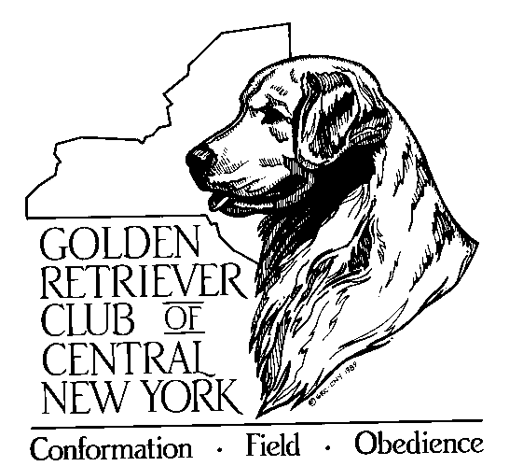
GOLDEN RETRIEVER CLUB
OF CENTRAL NEW YORK, INC.
P.O. Box 2812
Syracuse, NY 13220

Email: grccny@gmail.com

Dear GRC Member:

Club dues for 2023 are now payable. The deadline is December 31, 2022.

We hope you find your membership in GRCCNY (Golden Retriever Club of Central NY) worthwhile, and we welcome your support and participation in our activities, including Public Education that is so necessary. The club belongs to all of us; please give us feedback on ideas and suggestions and get involved.

Our newsletter, Golden Tales and website keep you informed of meetings, activities, announcements, etc. Two informative issues are published each year and our website www.grccny.org has updates, forms and more. In addition, you can find us on Facebook.

Please complete and return the form below along with your payment no later than December 31, 2022 to retain your membership. Membership renewals are due no later than December 31,2022. Any renewals postmarked between January 1-14 will incur a $10 late fee and any renewals not submitted by January 14, 2023 will receive a membership suspension and will not be in good standing with the club until the membership fee along with the late fee is received. I hope that you will also consider being involved as a voting member.

We look forward to seeing you in 2023 and hope to also see you at our Annual Banquet in December.

____________________________________CLIP_______________________________________________

Name (s)________________________________________________________________________________
Phone Number(s)______________________________ Email: _____________________________________
Address: _____________________________________ Dog Name(s): _______________________________
_____________________________________ _______________________________
_____________________________________ _______________________________

Activities (i.e. field, rally agility, etc.)__________________________________________________________

$_______ Circle membership type: Individual $25 Household $30 Associate $25
{NOTE: field associates (without Goldens) are required to volunteer at a club event}

Make check payable to GRCCNY
Send all to: GRCCNY, P.O. Box 2812., Syracuse, NY 13220-2812

