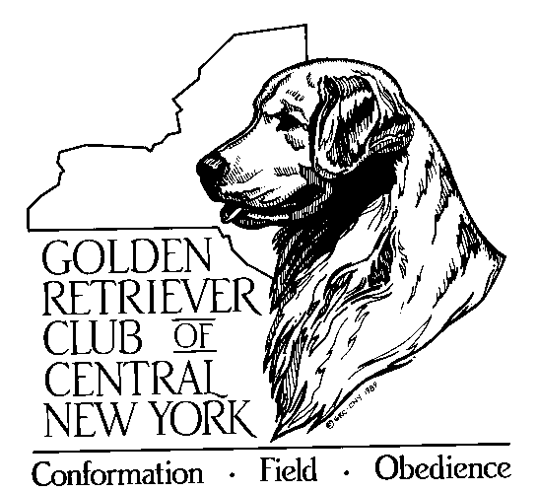
GOLDEN RETRIEVER CLUB
OF CENTRAL NEW YORK, INC.
P.O. Box 2812
Syracuse, NY 13220

Email: ckrehel@cnymail.com

Dear GRC Member:

Club dues for 2022 are now payable. The deadline is January 31, 2022.

We hope you find your membership in GRCCNY (Golden Retriever Club of Central NY) worthwhile and we welcome your support and participation in our activities, including Public Education that is so necessary. The club belongs to all of us; please give us feedback on ideas and suggestions and get involved.

Our newsletter, Golden Tales and website keep you informed of meetings, activities, announcements, etc. Two informative issues are published each year and our website www.grccny.org has updates, forms and more. In addition, you can find us on Facebook.

Please complete and return the form below along with your payment no later than January 31, 2022 to retain your membership. I hope that you will also consider being involved as a voting member.

We look forward to seeing you in 2022 and hope to also see you at our Annual Banquet in December.

____________________________________CLIP_______________________________________________
Name (s)________________________________________________________________________________

Phone Number(s)___________________________________________________________________________

Dog(s) name(s)___________________________________________________________________________

Activities (i.e. field, rally agility, etc.)__________________________________________________________

$_______ Circle membership type: Individual $25 Household $30 Associate $25
{NOTE: field associates (without Goldens) are required to volunteer at a club event}

Make check payable to GRCCNY
Send all to: GRCCNY, P.O. Box 2812., Syracuse, NY 13220-2812

Please update your email address for Golden Tales and other club correspondence:

______________________________________________________________________________________

